**CMSC203 Assignment 0**

Class: CMSC203 CRN 32295

 Program: Assignment 0

Instructor: Ahmed Tarek

 Summary of Description:

Part 1 –Setup GitHub(private)

Part 2 -Install JDK, Test java Application from Command Line

Part 3 - Install Eclipse, Test Eclipse Java Application

Part 4 - Install, Setup, Test Junit Program.

Part 5 - Install, Setup, and Test JavaFX Application.

 Due Date: 02/09/2021

 Integrity Pledge: I pledge that I have completed the programming assignment independently.

 I have not copied the code from a student or any source.

**Complete the following five parts of Assignment 0:**

**Part1: Setup GitHub:** Provide the screen shots of your GitHub account with Assignment 0 file is uploaded here:

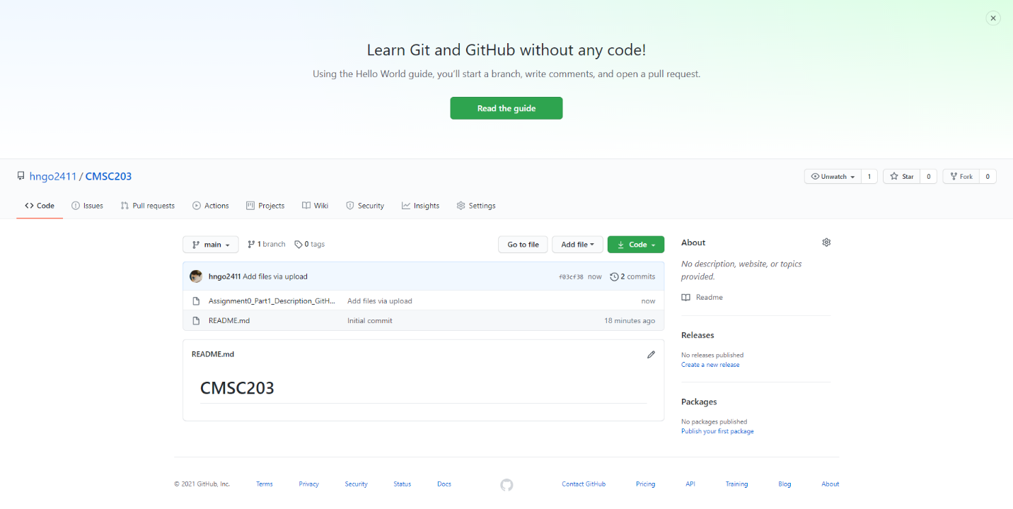

**Part 2 -Install JDK, Test java Application from Command Line**

Provide the screen shots from Step 1 and 2 here:

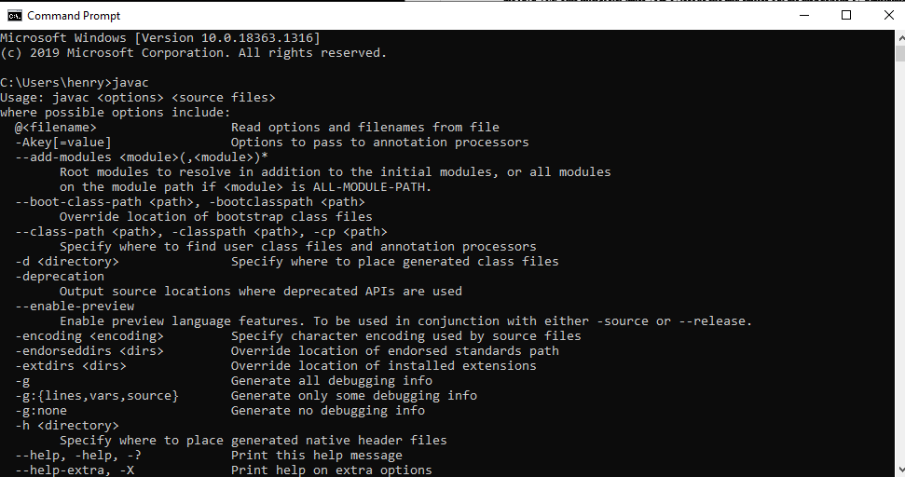

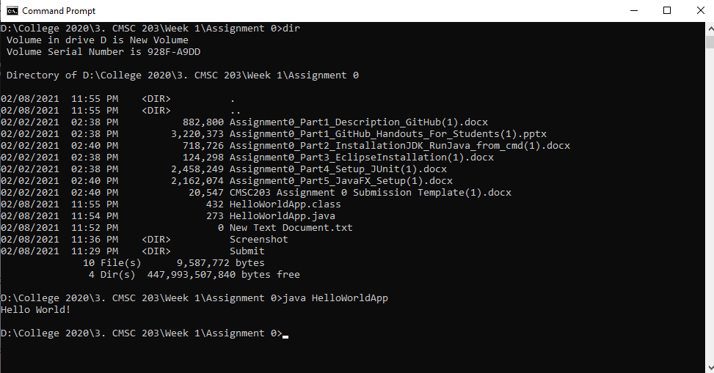

**Part 3 - Install Eclipse, Test Eclipse Java Application**

Provide the screen shots from Step 1 and 2 here:

Step 1

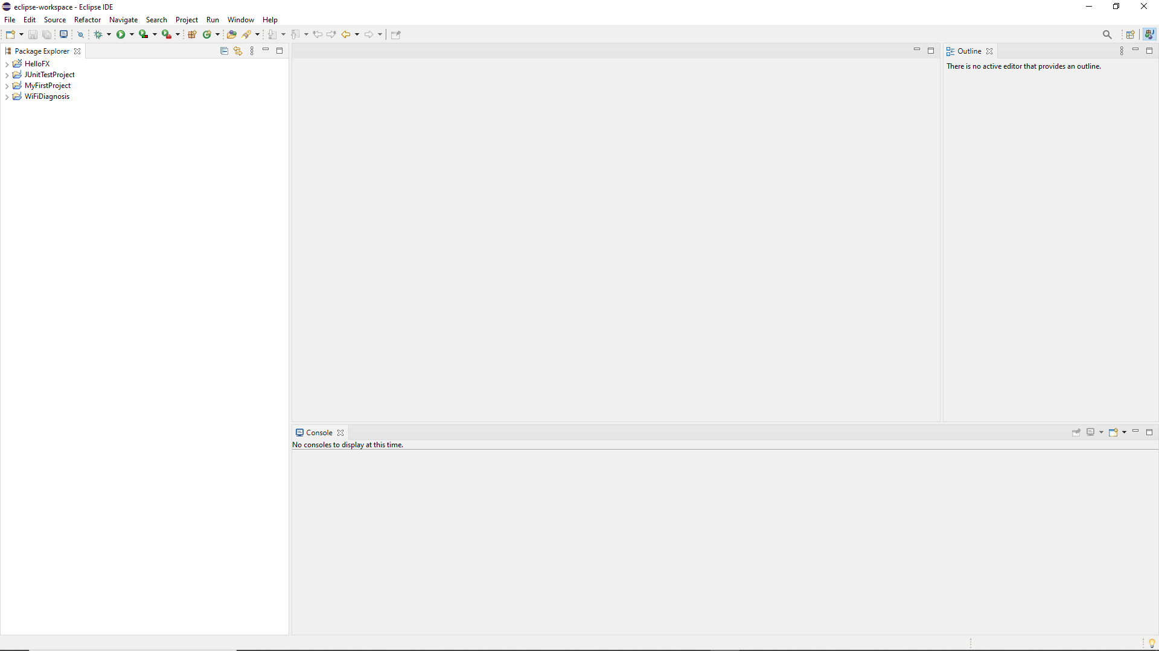

Step 2

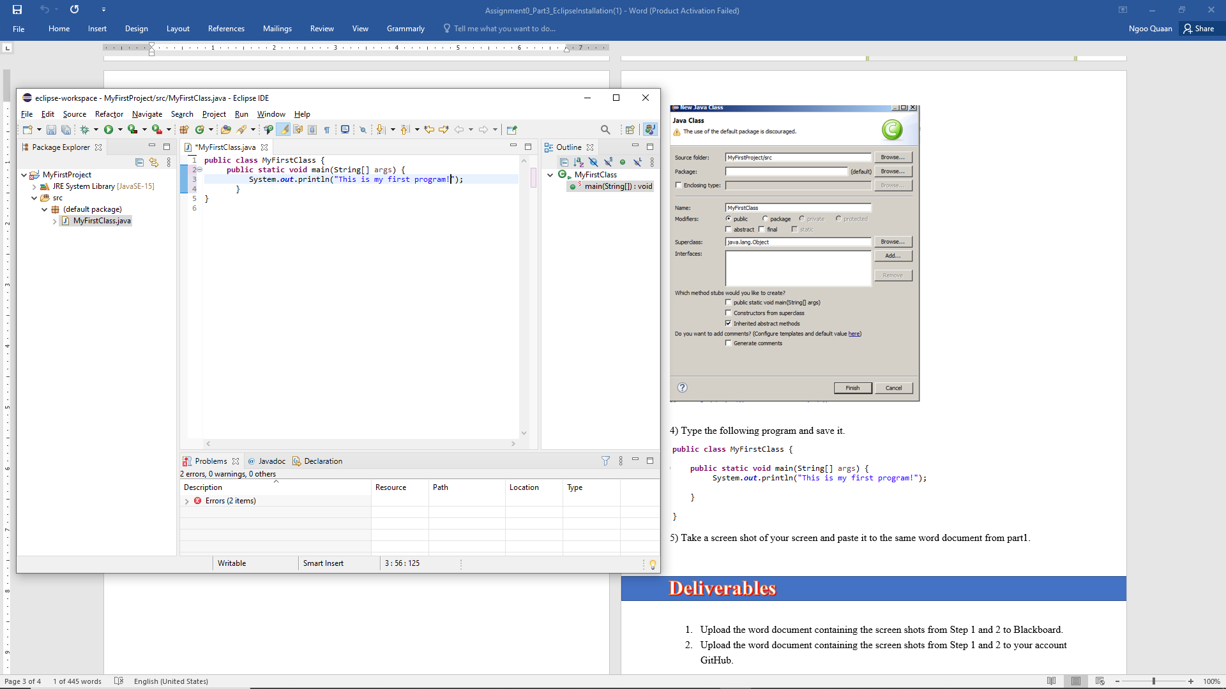

**Part 4 - Install, Setup, Test Junit Program.**

Provide the screen shots showing:

* 1. Eclipse with working JUnit Test example

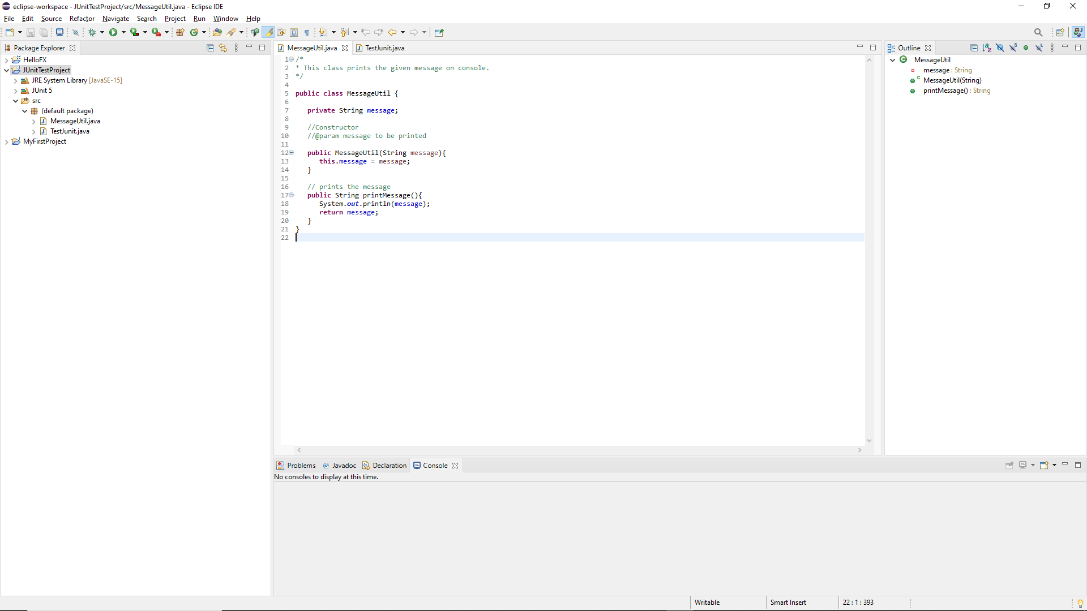

* 1. Project screenshot

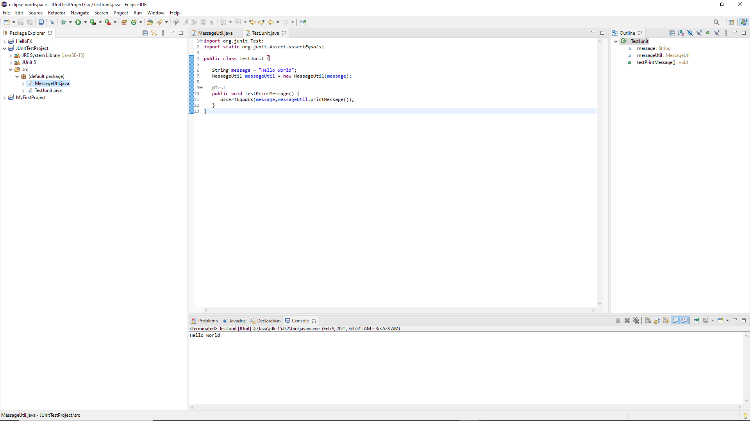

* 1. Running example screenshot

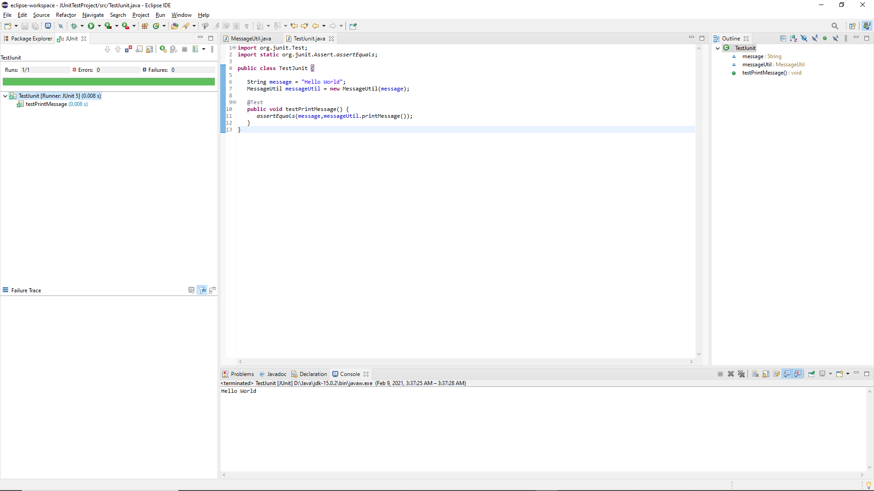

**Part 5 - Install, Setup, and Test JavaFX Application.**

Provide the screen shots showing:

1. JavaFX Project screenshot

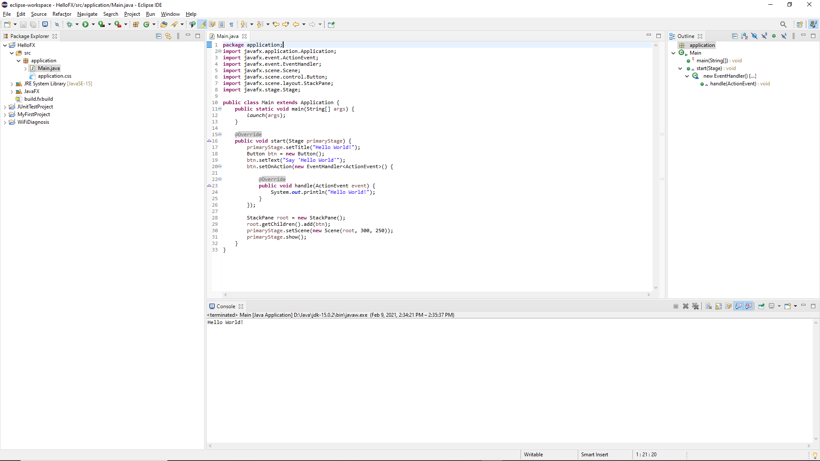

1. Running example screenshot

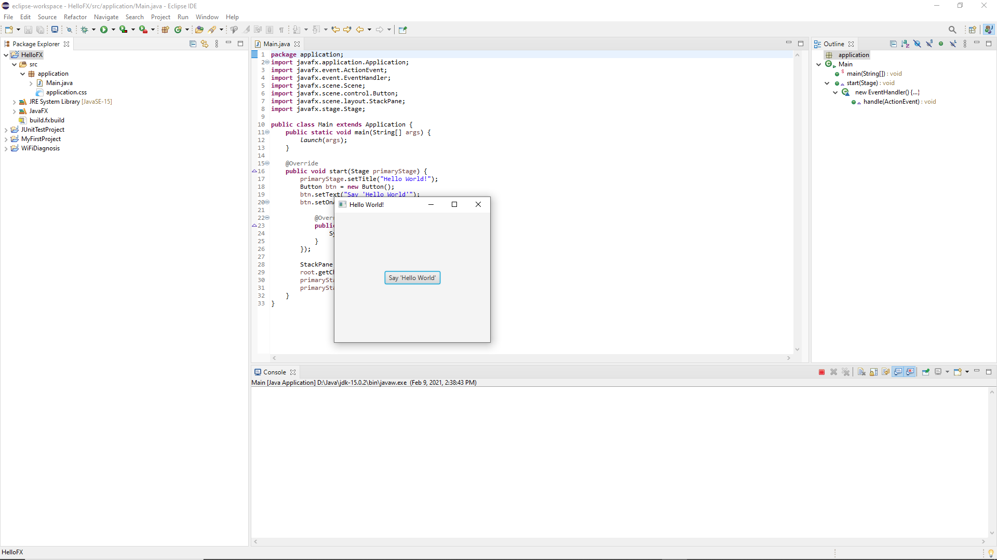

1. Java Source Code File

**Lessons Learned**

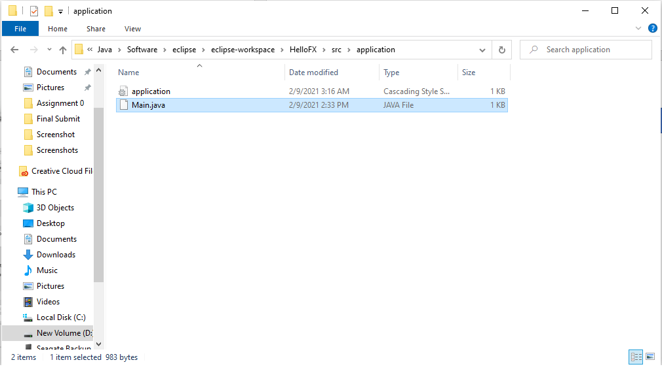

Write about your Learning Experience, highlighting your lessons learned and learning experience from working on this assignment.

What have you learned?

Learn to install set up javaFX, JDK, Test java app from cmd, set up github. As well as testing Junit

What did you struggle with?

Part 4 and 5 of this Project Instruction are extremely confusing.

What parts of this assignment were you successful with, and what parts (if any) were you not successful with?

Part 1 2 3 are easy enough

Part 4 and 5 are confusing and hard to understand because of the instructions

Provide any additional resources/links/videos you used to while working on this assignment.

**https://www.youtube.com/watch?v=_7OM-cMYWbQ&feature=youtu.be**

**Check List:** <Provide answers to the column Y/N or N/A >**:**

|  |  |  |  |
| --- | --- | --- | --- |
| **#** |  | **Y/N** | **Comments** |
|  | **Assignment files:** |  |  |
|  | * FirstInitialLastName_Assignment0.docx/pdf | **Yes or No** | **y** |
|  | * Source java files | **Yes or No** | **y** |
|  | **Program compiles** | **Yes or No** | **y** |
|  | **Program runs with desired outputs related to a Test Plan** | **Yes or No** | **y** |
|  | **Documentation file: Screenshots of** |  |  |
|  | * Part1: Setup GitHub | **Yes or No** | **y** |
|  | * Part 2 -Install JDK, Test java Application from Command Line | **Yes or No** | **y** |
|  | * Part 3 - Install Eclipse, Test Eclipse Java Application | **Yes or No or N/A** | **y** |
|  | * Part 4 - Install, Setup, Test Junit Program | **Yes or No or N/A** | **y** |
|  | * Part 5 - Install, Setup, and Test JavaFX Application. | **Yes or No or N/A** | **y** |
|  | * Lessons Learned | **Yes or No** | **y** |
|  | * Checklist is completed and included in the Documentation | **Yes or No** | y |